CropPredict: Smart Crop Recommendation and Yield Estimation Using Machine Learning
K.V.S. Jaswant  Department of Computer Science and Engineering  Koneru Lakshmaiah Education Foundation  Hyderabad, India  2420030467@klh.edu.in | D. Teja  Department of Computer Science and Engineering  Koneru Lakshmaiah Education Foundation  Hyderabad, India  2420030737@klh.edu.in | K Bhargav  Department of Computer Science and Engineering  Koneru Lakshmaiah Education Foundation  Hyderabad, India  2420030754@klh.edu.in
Dr. N. Sunanda
Assistant Professor
Department of Computer Science and Engineering
Koneru Lakshmaiah Education Foundation
Hyderabad, India

Abstract—Farmers and agricultural planners need to compare crop options and estimate expected yield from soil, weather, season and input conditions, yet the supporting data are usually scattered across spreadsheets and the resulting models rarely reach an interface a user can operate. This paper presents CropPredict, a Python and Streamlit application that combines dataset upload and schema checking, an auditable cleaning log, exploratory analysis, benchmarking of four regression models, a yield-prediction form, a ranked comparison of eight candidate crops, and an evaluation dashboard. Random Forest, Gradient Boosting, Decision Tree and Ridge regression are compared on a held-out test set using R², MAE and RMSE. On a dataset of 404 records (400 after removing four duplicates) with 11 attributes, Random Forest obtained the best test scores (R² = 0.9919, MAE = 0.934, RMSE = 2.261 t/ha), ahead of Gradient Boosting, Decision Tree and Ridge regression. The study positions its contribution as workflow integration and transparent reporting rather than a new learning algorithm. Because the dataset is small, the split is a single random 80/20 partition, and yields of different crops are compared on one scale, the results demonstrate system feasibility and are indicative guidance, not a validated agronomic forecast. The paper outlines a leakage-controlled evaluation protocol and the local data needed before field use.
Keywords—crop recommendation, crop yield prediction, machine learning, Random Forest, Gradient Boosting, data cleaning, Streamlit, decision support

I. Introduction
Agriculture underpins food security and rural livelihoods, and decisions about which crop to sow and how much to expect from it determine how seed, fertilizer and irrigation are allocated [5], [6]. Yield, however, is the outcome of interacting factors: rainfall, temperature, soil type, season, region, planted area and fertilizer use. Their effects are rarely linear, and yield can respond sharply once temperature passes crop-specific thresholds [4]. A farmer, student or extension worker therefore needs a structured way to compare crop options and to see an indicative yield estimate before cultivation.
Machine learning offers a data-driven alternative to manual estimates and historical averages because it learns nonlinear relationships directly from records. Systematic reviews report that Random Forest, neural networks and gradient-boosted trees are widely used for yield prediction, and that the choice of input features is at least as influential as the choice of algorithm [1]–[3]. Many prototypes nevertheless stop at a notebook or a table of error metrics. They seldom expose data cleaning, model comparison and a usable prediction interface in one place, and the quality of the input data is often not reported.
CropPredict addresses this problem through a web application with a shared workflow. A user uploads a dataset and checks its schema, reviews a cleaning audit log, explores the data, trains and compares four regression models, enters farm conditions to obtain a yield estimate, and ranks eight candidate crops under the same conditions. Dashboards for evaluation and a page on limitations complete the application.
The main contribution of this work is therefore integrative. The system does not propose a novel learning algorithm. It demonstrates how data-quality reporting, standard regressors evaluated under a common protocol, and an accessible interface can be combined. The paper is explicit about its boundaries: the dataset has 400 usable records, the evaluation is a single random split, and the outputs are guidance rather than guarantees. The rest of the paper is organized as follows. Section II reviews related work, Section III states the problem and objectives, Section IV describes the architecture, Section V the methodology, Section VI the benchmarking design, Section VII the dataset and implementation, Section VIII the results, and Sections IX to XIII cover the research gap, an evaluation protocol, limitations, future work and the conclusion.

II. Related Work and Literature Survey

A. Machine Learning for Crop Yield Prediction
Van Klompenburg et al. carried out a systematic review of machine-learning crop-yield studies and found that temperature, rainfall and soil type are among the most frequently used features, that many algorithm families are applied, and that performance varies across crops and regions [1]. This variation motivates evaluating several models on one dataset rather than assuming a single winner. Liakos et al. reviewed machine learning across agricultural domains and stressed that data quality and reliable target labels matter as much as model selection [2]. This supports the inclusion of an explicit data cleaning stage in CropPredict. Sharma et al. reviewed maize and soybean yield prediction and reported the use of Random Forest, neural networks, support vector machines and XGBoost, with temperature, precipitation, historical yield and soil pH frequently useful [3].
Four model families are relevant to this study. Random Forest averages many decorrelated trees built on bootstrap samples and provides a robust non-linear baseline [7]. Gradient boosting builds an additive model in stages, each tree correcting the residuals of the earlier ones [8], and XGBoost is an optimized implementation of the same idea [11]. A single Decision Tree yields readable rules but tends to overfit [9]. Ridge regression shrinks coefficients by penalizing their squared size, which stabilizes a linear model when predictors are correlated [10]. Together they form a linear baseline, an interpretable tree, and two ensembles, and all are available in scikit-learn [12].

B. Explainability
Predictions that cannot be questioned are difficult to adopt in agriculture. Lundberg and Lee proposed SHAP as a unified feature-attribution framework [13]. CropPredict currently reports a feature-importance ranking from the trained model on its model-comparison page. SHAP can be added later. Importance scores describe how a model uses its inputs, not how a crop responds to them, and should not be read as causal agronomic evidence.

C. Literature Survey
To position CropPredict, four recent crop-recommendation and yield-estimation studies were reviewed together with the three surveys above. They are summarized in Table I. Snotra et al. [14] compared SVM, Decision Tree, Random Forest and Naive Bayes on soil nutrients, temperature, humidity and rainfall, and reported that Random Forest performed best with 99.32% accuracy. Kathoon et al. [15] used a deep-learning model on N, P, K, pH, temperature, humidity and rainfall. Kumar et al. [16] combined crop recommendation and yield estimation using Random Forest on soil, climate and pH data, and Tomar et al. [17] compared several algorithms on soil, climate and crop-yield data.
TABLE I
Literature Survey of Related Studies
Study | Method / finding | Gap relative to CropPredict
Snotra et al. [14], 2025 | SVM, DT, RF, NB on soil, temperature, humidity, rainfall; RF best (99.32% accuracy) | Needs labelled soil-nutrient data; no season, irrigation or yield inputs
Kathoon et al. [15], 2025 | Deep learning on N, P, K, pH, temperature, humidity, rainfall | Needs lab soil values; black-box output
Kumar et al. [16], 2025 | Random Forest for crop recommendation and yield estimation | Depends on training data; limited regional coverage
Tomar et al. [17], 2024 | Several ML algorithms compared on soil, climate and yield data | Model-centric; no ranked, explainable shortlist
Van Klompenburg et al. [1], 2020 | Systematic review of ML crop-yield studies | Results differ across crops and regions
Liakos et al. [2], 2018 | Review of machine learning in agriculture | Strong dependence on data quality
Sharma et al. [3], 2025 | Review of maize and soybean yield prediction | Generalization and feature integration remain open

D. Summary of Reviewed Approaches
Prior work establishes that soil, weather and season variables are useful predictors, that Random Forest is a strong default for tabular agricultural data, and that results depend on the dataset and validation scheme. Several recommendation studies report high accuracy but depend on laboratory soil values or give model-centric outputs. None of the reviewed studies combines an auditable cleaning stage, a multi-model comparison, a yield-prediction form and a ranked crop comparison in one interface.

III. Problem Definition and Objectives
Farmers and agricultural learners need an accessible way to compare how different crops might perform under their conditions and to see an indicative yield estimate. Existing practice relies on manual estimates and historical averages, while standalone prediction experiments produce error metrics without an interface or a record of how the data were prepared. CropPredict frames the problem as an integrated decision-support workflow.
The objectives of the system are to:
- provide a web interface for uploading data and entering farm and environmental conditions;
- clean and validate the dataset and keep an auditable log of every step;
- train and compare multiple regression models under a common evaluation pipeline;
- estimate yield for user-entered conditions and rank candidate crops;
- present analytics and an evaluation dashboard for the trained models; and
- state the limitations of the system and the need for local validation.

IV. System Architecture
Fig. 1 summarizes the architecture. A user, who may be a farmer or analyst, interacts with a Streamlit front end to upload a dataset, enter farm parameters, view analyses and charts, and obtain a yield prediction and crop recommendation. A Python back end performs data ingestion from CSV or Excel files, preprocessing (cleaning, missing-value handling and feature selection), model training and prediction. The machine-learning pipeline splits the data, trains and evaluates several regressors, selects the best model and saves it with Joblib. Historical crop, weather and soil data feed the pipeline, and Plotly and Matplotlib generate the visualizations. The layering separates data preparation, analytical processing and user-facing action, which allows each stage to be tested independently and avoids presenting unvalidated source data directly as insight. The figure lists a generic linear regression; the linear baseline in the implemented comparison is Ridge regression.

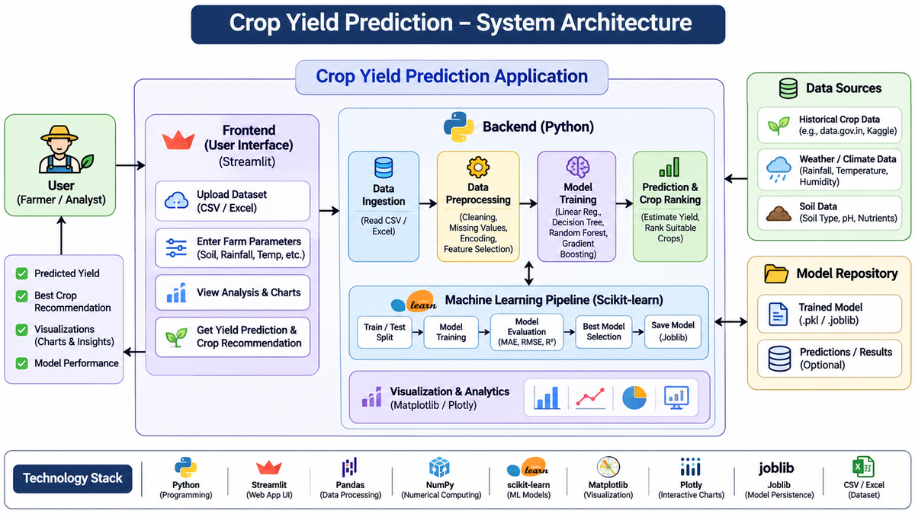
Fig. 1. Conceptual architecture of the CropPredict platform.

A. Application Modules
The interface is organized into nine pages, listed in Table II. Splitting the workflow into pages keeps each screen focused on one decision: data are checked before they are explored, explored before models are trained, and models are compared before they are used to predict. The application reports the loaded dataset and the selected model in a status panel so that the user always sees which data and model produced an output.
TABLE II
Application Modules
Module | Function
Home Dashboard | Overview of the application and its status
Upload Dataset & Schema | Load CSV/Excel data and inspect the schema
Data Cleaning & Preprocessing | Duplicate removal, missing values, outlier report, audit log
Exploratory Data Analysis | Distributions, correlations and summaries
Model Training & Comparison | Train four regressors and compare R², MAE, RMSE
Predict Crop Yield | Yield estimate from user-entered farm conditions
Recommend Best Crop | Ranked comparison of eight candidate crops
Model Evaluation Dashboard | Metrics and feature-importance ranking
About & Limitations | Assumptions and cautions for users

B. Data Ingestion and Quality
The ingestion layer reads a tabular file, checks that the expected columns are present, and passes the data to the cleaning stage. The cleaning page reports initial rows, cleaned rows, rows removed and active columns, lists each applied step with the number of rows affected, and provides an outlier detection report based on the interquartile-range (IQR) rule. These checks are included because duplicate rows, missing values and extreme values can distort both summary statistics and model outputs. Recording each transformation also makes the pipeline traceable and reproducible.

V. Methodology
CropPredict follows a staged workflow: data loading, cleaning, exploratory analysis, feature preparation, model training, evaluation, and prediction. The stages are described below.

A. Data Preparation
Exact duplicate rows are removed, missing numerical values are identified and handled in the preprocessing step, and outliers are reported by the IQR rule (values below Q1 − 1.5 IQR or above Q3 + 1.5 IQR). Outliers are reported for inspection. Extreme yields can be genuine, for example for crops with very high tonnage per hectare, so they should be examined before any decision to remove them.

B. Features and Target
The prediction form takes nine inputs: crop year, crop, season, state, annual rainfall, average temperature, soil type, cultivated area and fertilizer use. The target is yield in tonnes per hectare. Production in tonnes is not requested by the form. Because production equals yield multiplied by area, it must not be used as a predictor, since it would leak the target. Categorical variables (crop, season, state, soil type) are encoded in the preprocessing step.

C. Data Splitting and Pipeline
The data are divided into training and test sets using an 80/20 split with a fixed random seed (random_state = 42), which gives about 320 training and 80 test records for 400 cleaned rows. The preprocessing step and the model are packaged in a single scikit-learn pipeline, so that learned preprocessing such as imputation and encoding is fitted on training data only and then applied unchanged to test data and to new user inputs. This avoids a common source of information leakage and of discrepancy between experimental and deployed behavior.

D. Crop Ranking
For the crop-ranking page, the trained model predicts yield once for each of eight candidate crops (Sugarcane, Wheat, Rice, Maize, Barley, Groundnut, Soybean and Cotton), keeping all other user-entered conditions fixed, and sorts the predictions. The ranking therefore orders crops by expected yield per hectare under the entered conditions. It does not account for price, cost, water requirement or the agronomic suitability of the crop for the site.

VI. Machine Learning Benchmarking
The model laboratory benchmarks Random Forest, Gradient Boosting, Decision Tree and Ridge regression. The objective is comparative rather than algorithmic novelty. Each model receives the same feature representation and is evaluated on the same held-out data using R², MAE and RMSE for both the training and test sets. Using these four models is justified because they represent different learning approaches: a regularized linear baseline, an interpretable tree, a bagging ensemble, and a boosting ensemble. Reporting training and test scores together makes overfitting visible, and evaluating all models on identical data avoids selecting a model solely because of its name or a single metric.

A. Evaluation Metrics
With n test observations, observed yields y_i, predictions ŷ_i and mean observed yield ȳ, the metrics are:
RMSE = sqrt[(1/n) Σ(yᵢ − ŷᵢ)²] (1)
MAE = (1/n) Σ|yᵢ − ŷᵢ| (2)
R² = 1 − [Σ(yᵢ − ŷᵢ)² / Σ(yᵢ − ȳ)²] (3)
RMSE penalizes large errors more strongly and is expressed in tonnes per hectare. MAE is the average absolute error in the same units and is easier to explain to non-specialists. R² compares the model with a baseline that always predicts the mean. Lower RMSE and MAE and an R² closer to 1 indicate better agreement with observed yield. No single metric is sufficient, so all three are reported.

B. Model Comparison
Table III compares the four models qualitatively. Ridge regression is the linear baseline, the Decision Tree yields readable rules, Random Forest is a robust non-linear ensemble, and Gradient Boosting corrects residual errors sequentially.
TABLE III
Qualitative Comparison of the Regression Models
Model | Type | Interpretability | Role in this study
Ridge regression | Linear | High | Baseline
Decision Tree | Rule-based | High | Readable rules
Random Forest | Bagging ensemble | Medium | Robust non-linear model
Gradient Boosting | Boosting ensemble | Medium | Sequential error correction

VII. Dataset and Implementation

A. Dataset
The dataset loaded into the application has 404 records and 11 attributes, of which seven are numeric and four categorical. Initial screening found 8 missing values (0.18% of cells) and 4 duplicate rows (0.99% of rows). After removal of the duplicates, 400 records remain. Table IV lists the attributes. The dataset is small by machine-learning standards and covers a limited set of crops, seasons and states, so it supports a demonstration of the workflow but not claims of regional generality.
TABLE IV
Attributes of the Dataset
Attribute | Type | Description
Crop_Year | Numeric | Year of the record
Crop | Categorical | Crop grown
Season | Categorical | Growing season (e.g., Kharif)
State_Name | Categorical | State of the record
Annual_Rainfall_mm | Numeric | Annual rainfall in mm
Avg_Temperature_C | Numeric | Average temperature in °C
Soil_Type | Categorical | Soil type (e.g., Alluvial)
Area_Hectares | Numeric | Cultivated area in hectares
Fertilizer_Usage_kg | Numeric | Fertilizer applied in kg
Production_Tonnes | Numeric | Total production (not a model input)
Yield_Ton_Ha | Numeric | Target: yield in tonnes per hectare

B. Tools and Environment
The application is written in Python and developed in Visual Studio Code. Streamlit provides the interactive web interface, Pandas and NumPy handle loading, cleaning and numerical processing, and scikit-learn provides the models, pipeline and metrics. Matplotlib and Plotly produce static and interactive charts, Joblib saves and loads trained models, and Openpyxl reads Excel files. A standard laptop or desktop is sufficient, no GPU or special hardware is needed, and the application runs locally on Windows, macOS or Linux. Table V lists the tools. The lightweight architecture was chosen so that the complete workflow can be demonstrated without a production back end.
TABLE V
Tools Used in the Implementation
Purpose | Tool
Language / editor | Python, VS Code
Web interface | Streamlit
Data handling | Pandas, NumPy, Openpyxl
Machine learning | scikit-learn
Visualization | Matplotlib, Plotly
Model persistence | Joblib
Data formats | CSV, Excel

C. Testing and Validation
The application was checked with the dataset for the functional cases listed in Table VI: uploading a valid CSV file, handling missing values, training the regression models and generating a yield prediction. All four cases passed. These are functional checks of the application, not a validation of the predictions against field outcomes.
TABLE VI
Functional Test Cases
ID | Test | Expected result | Status
TC-01 | Upload valid CSV dataset | Dataset uploaded and preview displayed | Pass
TC-02 | Handle missing values | Missing values identified and handled | Pass
TC-03 | Train ML regression model | Model trains and metrics are displayed | Pass
TC-04 | Predict crop yield | Yield displayed for valid inputs | Pass

VIII. Results and Discussion

A. Data-Quality Findings
Fig. 2 shows the cleaning audit log. One cleaning step was applied: four identical duplicate rows were removed, reducing 404 rows to 400 with 11 active columns. The IQR outlier report flags 67 records for yield, 61 for production, 19 for area, 2 each for temperature and fertilizer use, 1 for rainfall and none for crop year. The upper IQR bound for yield is 7.188 t/ha, so the flagged yields are probably dominated by crops with very high tonnage per hectare such as sugarcane, which are genuine rather than erroneous. This matters for interpretation, because a pooled model must learn very different yield scales.
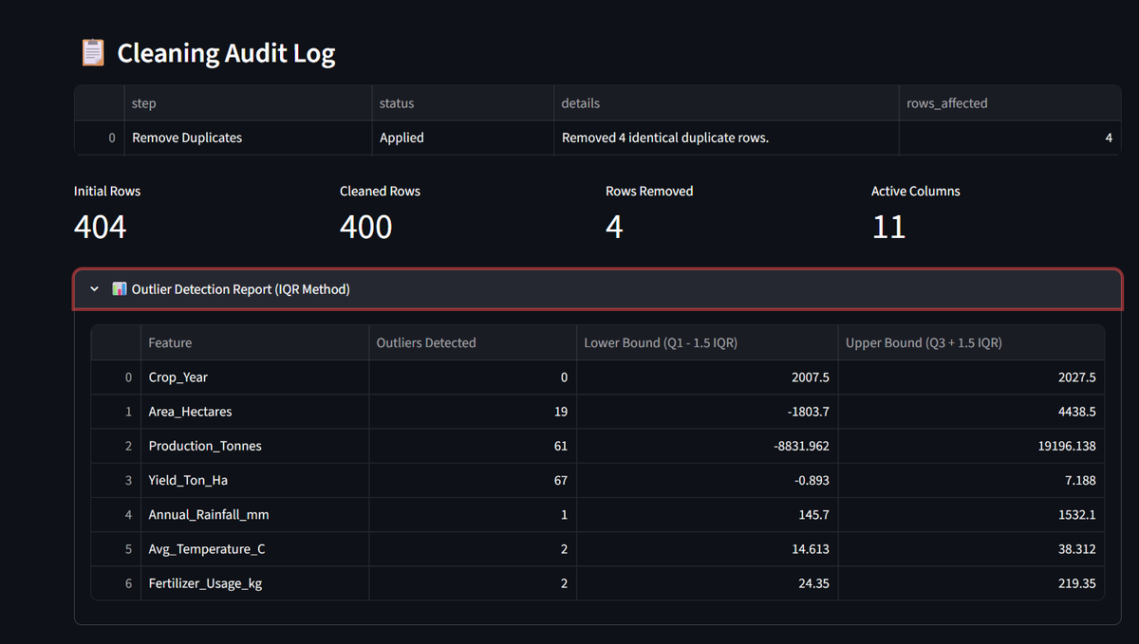
Fig. 2. Cleaning audit log and IQR outlier detection report.

B. Benchmark Results
Table VII reports the performance of the four models on the held-out test set, with training scores for comparison, and Figs. 3 and 4 plot the test errors and the train–test gap. Random Forest obtained the best test R², MAE and RMSE. Its test RMSE of 2.261 t/ha is about 38% lower than that of Ridge regression (3.623), and its test MAE of 0.934 is about 62% lower than Ridge (2.487). Gradient Boosting was second (R² = 0.9891), followed by Decision Tree (0.9795) and Ridge (0.9791).
TABLE VII
Model Performance on Train and Held-out Test Sets
Model | Test R² | Test MAE | Test RMSE | Train R² | Train MAE | Train RMSE
Random Forest | 0.9919 | 0.934 | 2.261 | 0.9988 | 0.310 | 0.829
Gradient Boosting | 0.9891 | 1.102 | 2.621 | 1.0000 | 0.025 | 0.033
Decision Tree | 0.9795 | 1.441 | 3.590 | 0.9993 | 0.237 | 0.632
Ridge regression | 0.9791 | 2.487 | 3.623 | 0.9825 | 1.922 | 3.159

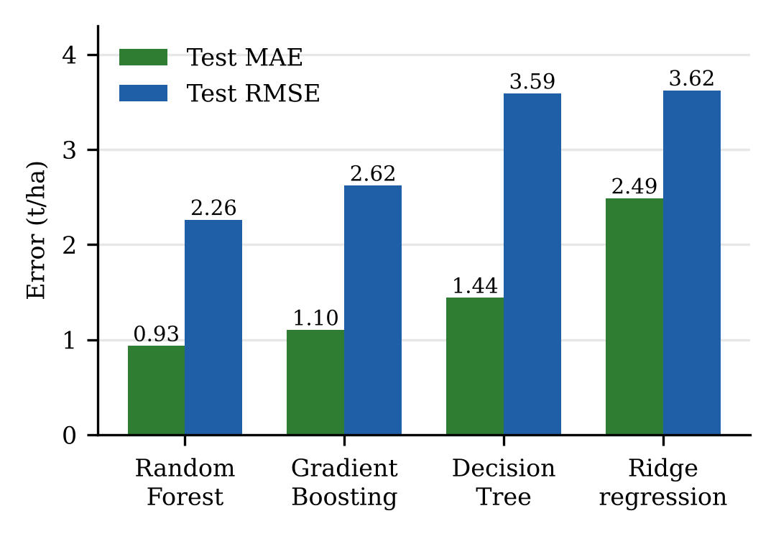
Fig. 3. Test-set MAE and RMSE of the four models (lower is better).
Fig. 3 shows that the ordering by error is the same for MAE and RMSE: Random Forest, Gradient Boosting, Decision Tree, then Ridge regression. The advantage of Random Forest over Ridge is large in MAE (0.934 against 2.487 t/ha) and smaller, but still clear, in RMSE (2.261 against 3.623 t/ha). Because RMSE exceeds MAE for every model, a few large errors, most likely on the high-yield crops, contribute strongly to the squared-error measure.
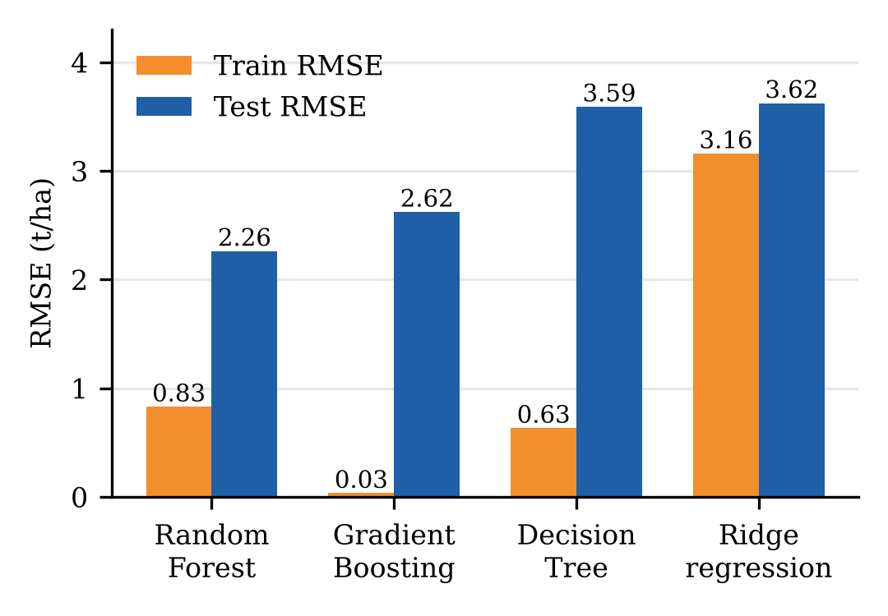
Fig. 4. Training and test RMSE of the four models.
Fig. 4 compares training and test RMSE. The three non-linear models fit the training data much more closely than the test data: the Gradient Boosting training RMSE is 0.033 against 2.621 on the test set, and Random Forest rises from 0.829 to 2.261. Ridge regression shows a much smaller gap (3.159 to 3.623) but a higher error overall. The tree-based models therefore generalize better in absolute terms yet show clear overfitting, which is expected for 320 training records.
The results should be interpreted cautiously. The test R² values of all four models are close, and the differences in MAE and RMSE are more informative than those in R². High R² is also expected when yields of crops with very different scales are pooled, because much of the variance lies between crops rather than within them. With a single random split and one random seed, the ranking of the tree-based models may change under repeated or blocked validation. The benchmark is therefore useful for comparing models under controlled conditions but cannot establish real-world superiority.

C. Crop Recommendation
Fig. 5 and Table VIII show the output of the recommendation page for one set of user-entered conditions. Sugarcane ranks first with a predicted 67.38 t/ha among the eight candidate crops, followed by Wheat (4.14), Rice (3.58), Maize (2.99), Barley (2.91), Groundnut (2.48), Soybean (2.27) and Cotton (1.82). The very large gap between Sugarcane and the other crops reflects the different nature of the crop, whose yield is measured as harvested cane tonnage, and does not mean that Sugarcane is the most suitable or most profitable choice. Ranking by raw yield per hectare therefore favors high-tonnage crops by construction. This is a key limitation of the current ranking and is discussed in Section XI.
TABLE VIII
Predicted Yield for Eight Candidate Crops (Example Input)
Rank | Crop | Predicted yield (t/ha) | Note
1 | Sugarcane | 67.38 | High-tonnage crop
2 | Wheat | 4.14 | Highest among the other seven crops
3 | Rice | 3.58 | -
4 | Maize | 2.99 | -
5 | Barley | 2.91 | Matches the Fig. 6 prediction
6 | Groundnut | 2.48 | -
7 | Soybean | 2.27
8 | Cotton | 1.82

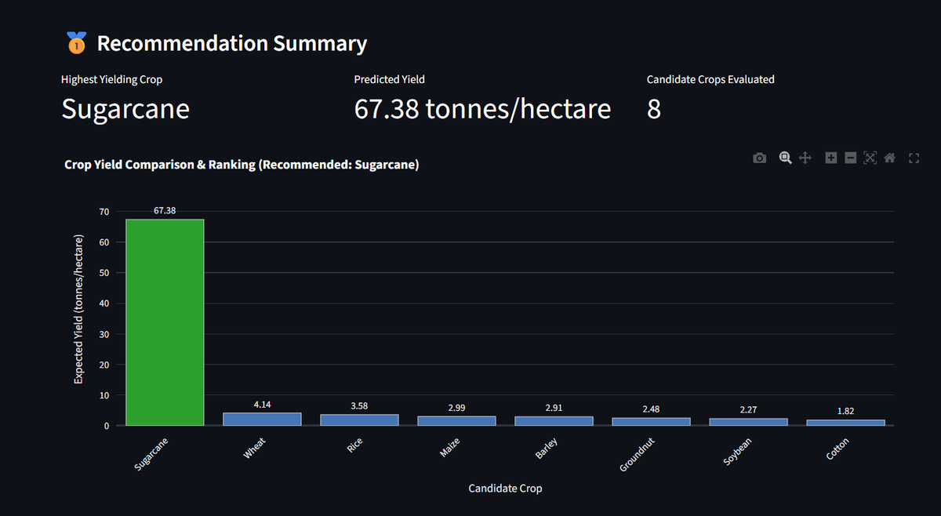
Fig. 5. Recommendation summary and crop yield ranking.

D. Yield Prediction Example
Fig. 6 shows the prediction page. For Barley grown in the Kharif season in Gujarat, with 861.4 mm of rainfall, an average temperature of 26.7 °C, Alluvial soil, 1144.65 ha of area, 120.8 kg of fertilizer and crop year 2018, the application returns an estimated yield of 2.91 t/ha, which agrees with the Barley entry in the ranking. Each numeric field displays the historical range of the dataset, so the user can see when an input lies outside the data the model was trained on.
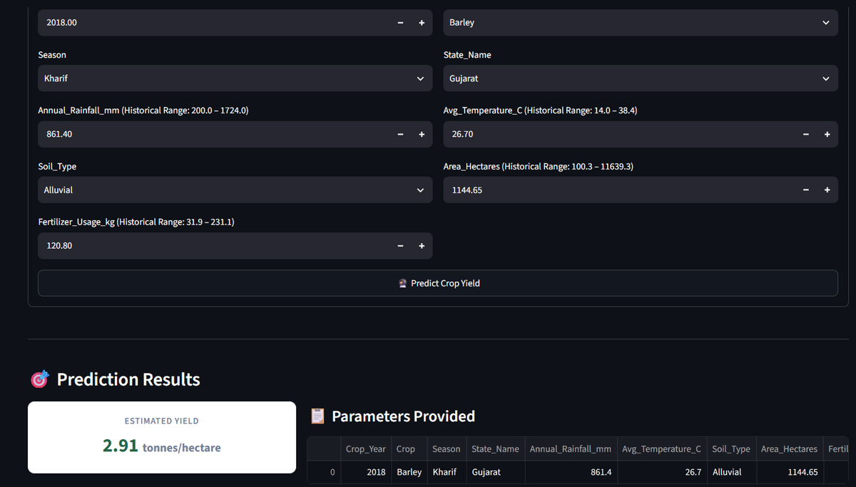
Fig. 6. Farm-condition input form and predicted yield.

E. Advantages of the Proposed System
The system offers one workflow from raw data to prediction, an auditable cleaning log, a fair multi-model comparison with train and test metrics side by side, historical input ranges that guard against out-of-range queries, and a ranked crop comparison. Its lightweight design runs on a standard laptop and needs no specialized hardware.

F. Threats to Validity
Internal validity is limited because the evaluation uses one random 80/20 split and one seed on 400 records, so related records may appear in both training and test sets. External validity is limited because the data cover a restricted set of crops, seasons and states. Construct validity is limited because yield per hectare of different crops is compared on one scale, so the ranking is not an agronomic suitability score. These threats are addressed by the evaluation protocol of Section X.

IX. Research Gap and Positioning
The reviewed literature establishes substantial work on crop recommendation, yield prediction and the comparison of machine-learning models [1]–[3], [14]–[17]. The gap addressed by CropPredict is not the absence of research in these areas. It is the integration, in one interface, of an auditable data-cleaning stage, a multi-model comparison with train and test metrics, a yield-prediction form with historical input ranges, and a ranked comparison of candidate crops.
This positioning avoids the stronger and hard-to-defend claim that no existing tool offers such features. The contribution is better described as an applied system-design study that makes the relationship between data quality, model comparison and user-facing decision support explicit.

X. Recommended Evaluation Protocol
A stronger empirical evaluation should replace the single random split with validation that respects the structure of agricultural data. Records from the same year or state share weather and management, so a random split places near-duplicates in training and test sets and overstates accuracy [1]. Leave-one-year-out validation tests whether a model predicts a new season, leave-one-state-out validation tests spatial generalization, and rolling-origin validation respects the direction of time. Learned preprocessing must be fitted on training folds only.
Results should be reported over repeated runs or folds with their spread, not a single value, and compared with simple baselines such as the crop-wise mean yield and last year's yield, so that the benefit of each model can be judged. Metrics should be reported separately for each crop, because a pooled R² can be dominated by between-crop differences, and relative errors such as RMSE divided by mean yield allow comparison across crops. This staged evaluation is justified because it shows whether the reported accuracy comes from learning weather and soil effects or from recognizing crop identity. Application evaluation should be conducted separately and should include import correctness, task completion time and usability with farmers or extension workers.

XI. Limitations
- The dataset has only 400 usable records and a restricted set of crops, seasons and states, so it is not representative of a whole region.
- Evaluation uses a single random 80/20 split and one seed, which can overstate accuracy and does not test generalization to new seasons or states.
- Tree-based models show a train–test gap, indicating some overfitting on a small dataset.
- Crop ranking compares yield per hectare across crops with very different units of harvest, so it favors high-tonnage crops and is not a suitability or profit score.
- The estimates are indicative guidance, not agronomic forecasts. Local soil tests and weather information must be checked before cultivation.
- Feature importance describes how the model uses inputs, not causal effects, and correlated variables can share importance.
- The application runs locally with no authentication, back end or database, so it is not suitable for sensitive production data.

XII. Future Work
The next stage should add district-level soil tests, weather history, crop varieties and local recommendations, and calibrate the models on reliable local agricultural data. Additional models such as XGBoost [11], neural networks and sequence models can be benchmarked against the current baselines, and a baseline-only comparison should accompany them. On the analytical side, future work can add SHAP explanations [13], prediction intervals and per-crop models, together with a crop-suitability score that accounts for agronomic requirements and economics.
On the engineering side, a validated back-end prediction API with secure hosting, monitoring and reliable data management should be introduced before any deployment. Applications include preliminary crop comparison, agricultural education and farm-planning support for farmers, students and educators. A user study with farmers and extension workers should assess whether the interface improves their decisions.

XIII. Conclusion
CropPredict demonstrates an integrated approach to crop recommendation and yield estimation. It combines dataset checking, an auditable cleaning stage, exploratory analysis, benchmarking of four regression models, a yield-prediction form and a ranked comparison of eight candidate crops in one application. On the 400 cleaned records, Random Forest achieved the best held-out scores (R² = 0.9919, MAE = 0.934, RMSE = 2.261 t/ha). The central contribution is the integration of these functions rather than a new algorithm.
The project is deliberately positioned as a reference implementation and system-design study. Its small dataset, single random split and cross-crop yield ranking mean that the results demonstrate feasibility and cannot establish real-world accuracy. With blocked validation, local data and a user study, CropPredict can provide a practical foundation for connecting agricultural data analysis to transparent decision support.

Acknowledgment
The authors thank Dr. N. Sunanda, Department of Computer Science and Engineering, KL University, for guidance and academic support throughout the project. K.V.S. Jaswant coordinated the project and integrated the interface, D. Teja developed the prediction workflow, and K. Bhargav handled analytics, testing and documentation.

References
[1] T. van Klompenburg, A. Kassahun, and C. Catal, “Crop yield prediction using machine learning: A systematic literature review,” Computers and Electronics in Agriculture, vol. 177, Art. no. 105709, 2020.
[2] K. G. Liakos, P. Busato, D. Moshou, S. Pearson, and D. Bochtis, “Machine learning in agriculture: A review,” Sensors, vol. 18, no. 8, Art. no. 2674, 2018.
[3] R. K. Sharma, J. Kaur, G. Feng, Y. Huang, C. Kumar, Y. Wang, S. Sharma, J. Jenkins, and J. Dhillon, “Maize and soybean yield prediction using machine learning methods: A systematic literature review,” Discover Agriculture, vol. 3, Art. no. 64, 2025.
[4] W. Schlenker and M. J. Roberts, “Nonlinear temperature effects indicate severe damages to U.S. crop yields under climate change,” Proc. National Academy of Sciences, vol. 106, no. 37, pp. 15594–15598, 2009.
[5] D. Tilman, C. Balzer, J. Hill, and B. L. Befort, “Global food demand and the sustainable intensification of agriculture,” Proc. National Academy of Sciences, vol. 108, no. 50, pp. 20260–20264, 2011.
[6] D. K. Ray, N. D. Mueller, P. C. West, and J. A. Foley, “Yield trends are insufficient to double global crop production by 2050,” PLoS ONE, vol. 8, no. 6, Art. no. e66428, 2013.
[7] L. Breiman, “Random forests,” Machine Learning, vol. 45, pp. 5–32, 2001.
[8] J. H. Friedman, “Greedy function approximation: A gradient boosting machine,” Annals of Statistics, vol. 29, no. 5, pp. 1189–1232, 2001.
[9] J. R. Quinlan, “Induction of decision trees,” Machine Learning, vol. 1, no. 1, pp. 81–106, 1986.
[10] A. E. Hoerl and R. W. Kennard, “Ridge regression: Biased estimation for nonorthogonal problems,” Technometrics, vol. 12, no. 1, pp. 55–67, 1970.
[11] T. Chen and C. Guestrin, “XGBoost: A scalable tree boosting system,” in Proc. 22nd ACM SIGKDD Int. Conf. Knowledge Discovery and Data Mining, 2016, pp. 785–794.
[12] F. Pedregosa et al., “Scikit-learn: Machine learning in Python,” J. Machine Learning Research, vol. 12, pp. 2825–2830, 2011.
[13] S. M. Lundberg and S.-I. Lee, “A unified approach to interpreting model predictions,” in Advances in Neural Information Processing Systems 30, 2017, pp. 4765–4774.

